2.2 Adaptations for gas exchange
1. Living things need to obtain materials such as carbon dioxide and oxygen from the environment and remove waste from their cells to the environment.
Organisms are differently adapted so gas exchange can take place whether it be in water or on land. In particular oxygen is needed to convert organic molecules into energy through the process of respiration.
NB: Gas exchange is the process by which oxygen reaches cells and waste products are removed, don’t confuse with respiration which is energy production in cells.

2. Requirements may be proportional to volume however diffusion is proportional to surface area

3. In large organisms the surface area to volume ratio is much less than in very small organisms.
As organisms get larger their volume to surface area increases meaning they cannot rely on diffusion alone as the diffusion path would be too long.

4. In small, unicellular organisms the surface area to volume ratio is so large that diffusion through the body surface is sufficient to supply their needs.
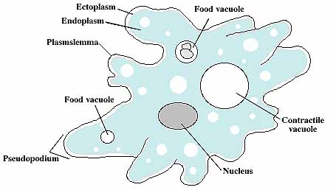
An example of this is an amoeba where the cell membrane acts as the exchange surface, It is thin and moist so is efficient at its job.

5. Also, distances within the body are small and transport by diffusion is again sufficient, e.g. Amoeba,
its size and lifestyle in water enables diffusion to supply its needs. The cell membrane has a large diffusion path and large surface area to volume ratio.

6. Larger, multicellular organisms may have a surface area to volume ratio which is too small to supply all their needs.

Multicellular organisms are an aggregation of cells. Cells aggregate together to increase their size but decreases their surface area to volume ratio and the diffusion path increases also materials are needed to be exchanged between different organs as well as the organism and the environment. So diffusion is no longer a viable process of exchange.

7. These organisms therefore possess special surfaces for gaseous exchange, gills for aquatic environments, lungs for terrestrial environments.

Gas exchange surfaces such as the gills of a fish, the alveoli in the lungs of a mammal, the trachae of an insect and the spongy mesophyll cells in the leaves of a plant are effective exchange surfaces.

8. These exchange surfaces have particular properties to aid diffusion: large surface area; thin, moist, permeable surface.

In order to achieve the maximum rate of diffusion a respiratory surface must:
- have a large surface area compared to volume
- be thin so diffusion paths are short
- moist to allow a medium for gasses dissolve in before diffusion
- maintain a concentration gradient so diffusion will take place.

9. The large moist area for gaseous exchange is a region of potential water loss.

10. Earthworms are multicellular, terrestrial animals restricted to damp areas. A moist body surface for diffusion, with a circulatory system and blood pigments, increase efficiency of gaseous exchange sufficient for a slow moving animal.

Simple multicellular animals such as worms have a low oxygen requirement as they have an extremely low metabolic rate as they move very slowly. Oxygen and carbon dioxide are able to diffuse across the skin surface so no gas exchange surface is required.
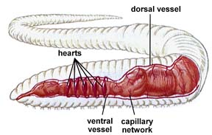
Earthworms:
- Elongated shape ensures a larger surface area to volume ratio enabling diffusion to take place.
- Low metabolic rate so does not require much oxygen.
- Mucus is secreted to keep the skin moist.
- They possess a simple circulatory system: a closed blood system containing blood within vessels .
- The blood contains a respiratory pigment that transports oxygen.
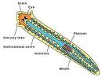
- Oxygen is carried to the cells whilst carbon dioxide is transported in the opposite direction, thus maintaining the diffusion gradient at the respiratory surface.
Flatworms:
- Flattened shape increases the SA: V and ensures a short diffusion path for exchange.
- Lives in aquatic environments

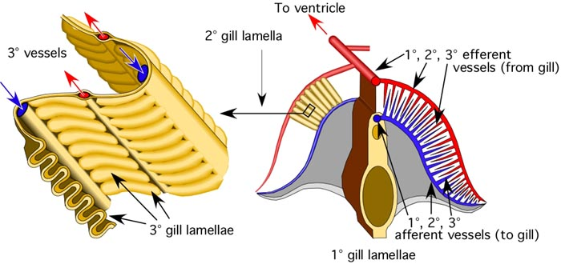

11. Bony fish are larger and more active. Their needs are supplied by a specialised area, the gills, with a large surface extended by gill filaments.

In fish gaseous exchange happens at the gill.
At the gill a specialised pumping mechanism pumps a one way current of water over the surface.
The density of the water keeps the gills from collapsing in on themselves which would reduce surface area.
Gills are made up of many folds providing a large surface area.

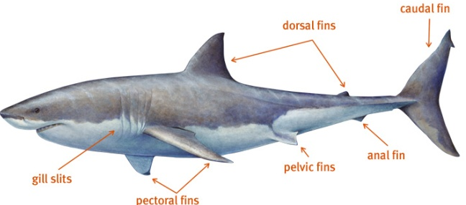
Fish can be further classified into two groups according to the material that makes up their skeleton.
Cartilaginous fish:
- Skeletons are made entirely of cartilage.
- Normally live in the sea e.g. shark
- Characterised by five gill clefts that open at five gill slits.
- Gas exchange involves parallel flow.
- Therefore blood travels through the capillaries in the same direction as the sea water.
- This is relatively inefficient as a diffusion gradient is not maintained.

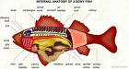
Bony Fish:
- internal skeleton made of bone
- gills are covered by the operculum
- Gas exchange involves Counter current flow.
- Blood in the capillaries flow in the opposite direction to the water flowing over the gill surface.
- This is more efficient as the gradient is maintained and exchange is able to happen over the whole gill surface

12. Water is a dense medium with a low oxygen content, therefore, to increase efficiency, it needs to be forced over the gill filaments by pressure differences so maintaining a continuous, unidirectional flow of water.

- A lower pressure is maintained in the opercula cavity than in the bucco-pharynx.
- The operculum acts as a valve
- It also acts as a pump drawing water over the gill filaments.

The ventilation mechanism for forcing water over the gill is:
mouth | Opens
operculum | Closes
Floor of buccal cavity | lowered
volume | increases
pressure | decreases
Water flows in

13. The gills have an extensive network of blood capillaries to allow efficient diffusion and haemoglobin for oxygen carriage.

14. Compared with parallel flow, counter current flow increases efficiency because the diffusion gradient between the adjacent flows is maintained over the whole surface.

Blood flows between the gill plates under pressure in the opposite direction the blood in the capillaries. The blood always meets water with higher oxygen content than itself. It removes 80% of the oxygen from the water. This high level of extraction is important as there is 25% less oxygen in water than in air.

15. Terrestrial vertebrates have adapted for exchange with air, a less dense medium, instead of water, so have internal lungs.
16. Internal lungs minimise loss of water and heat.
17. Amphibians have a larval form (tadpole) which develops in water and undergoes metamorphosis into the adult form.

This was likely the first vertebrate group to colonise the land. They have lungs for use on land but in water gas exchange occurs through diffusion as they have permeable moist skin which acts as a respiratory surface. the tadpole have gills for use in water.

18. The inactive frog uses its moist skin as a respiratory surface but when active uses lungs.

19. Reptiles and birds have more efficient lungs than amphibians.
Reptiles:
- Ribs protect the inner organs and provide ventilation to the lungs.
- Tissues in lungs provide a greater surface area.
Birds:
- Large volumes of oxygen are needed for flight.
- ventilation of the lungs are assisted by air sacs
- the action of flight muscles ventilate the lungs.

